**Report A4 Regression.**

Graph for N = 1, we got airline as NW

Weekly Median price for each year for carrier NW is depicted from the below graph.

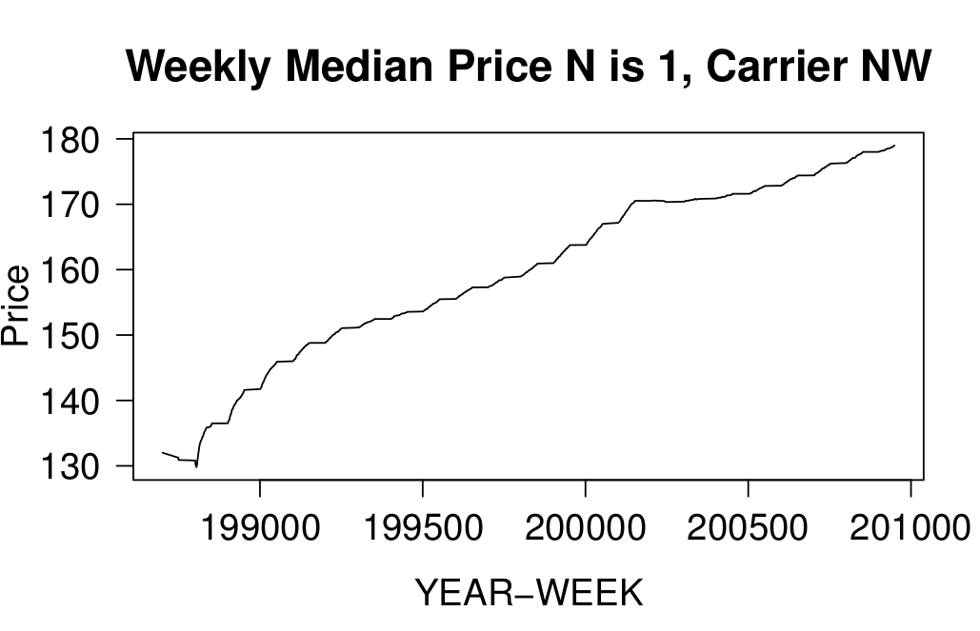

Assumed price policy: Ticket Price = Base Price + K($) x Time(minutes)

Conclusions from the Graph:

1) Higher median price indicates longer distance flights.

2) If the carrier has to earn more money they can increase K but not the base price.

3) If they are providing shorter flights then definitely buy it. Since there base price is low and they charge higher K. For shorter flights compared to other carrier this one is cheaper.

Graph for N = 200, we got airline as WN

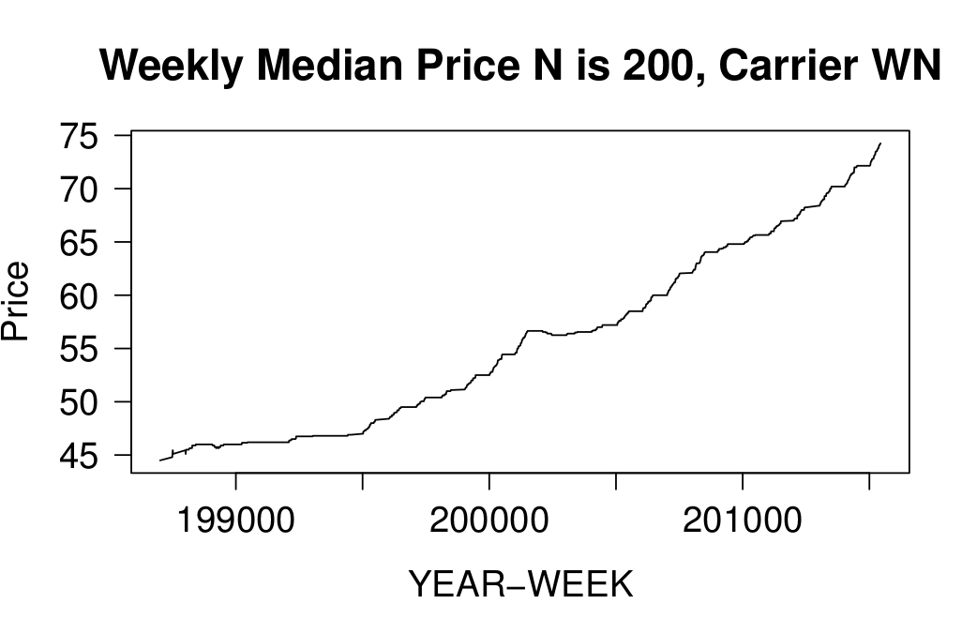Weekly Median price for each year for carrier WN is depicted from the below graph.

Conclusions from the Graph:

1) Lower median price indicates shorter distance flights.

2) If the carrier has to earn more money they can increase base price than K.

3) If they are providing longer flights then definitely buy it. Since there base price is high and they charge lower K. For longer flights compared to other carrier this one is cheaper.